SINGLETON PATTERN IMPLEMENTED IN JAVA
The Singleton Pattern is a design pattern that ensures only one object of a class is created throughout the application.
Key Points in code
- Private Constructor
  - Prevents creating objects using new.
- Static Instance Variable
  - Stores the single object of the class.
- Public Static Method (getInstance())
  - Returns the same object whenever called.
CODE:-
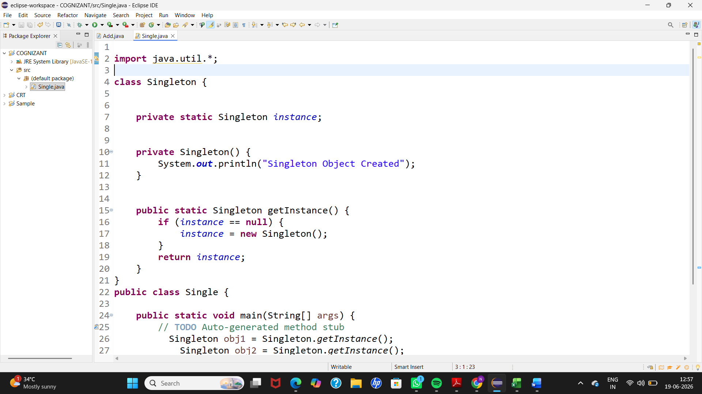
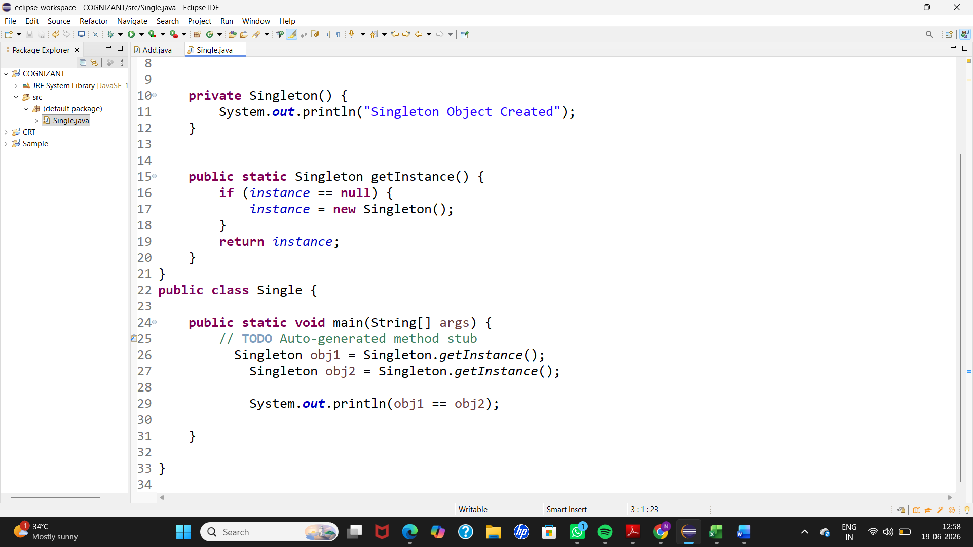

OUTPUT:-


